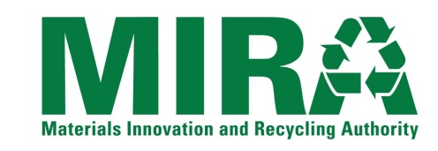
NOTICE OF INTEREST FORM
Individuals and firms that have an interest in the Materials Innovation and Recycling Authority (“MIRA”) solicitation listed below are encouraged to submit this Notice Of Interest Form to MIRA as early as they can. Forms should be submitted no later than the date specified below. Request For Bids/Proposals/ Qualifications documents and other information released by MIRA related to the solicitation will be directly provided to those firms that have submitted this Form to MIRA by the Form Due Date.
Solicitation: | RFP For Private Developers To Access And Use MIRA Properties For The Development Of Zero Carbon Resources
RFP Number: | RFP 19-OE-001
Form Due Time/Date:  (Please Indicate Site of Interest) | Prior to MANDATORY pre-proposal conferences and site tours on:  Wednesday July 11, 2018, 1:30pm – Waterbury Landfill – Corner of Highland Avenue and Highview Street, Waterbury, CT  Thursday July 12, 2018, 1:30 PM – Ellington Landfill – 217 Sadds Mill Road, Ellington, CT
Provide the following information about the individual/firm and the contact person for the firm.
Name of Individual/Firm:
Name of Contact Person:
Title of Contact Person:
Mailing Address 1:
Mailing Address 2:
City, State, Zip Code
Telephone Number:
Fax Number:
E-Mail Address:
Submit this form to the MIRA contact listed below via e-mail, fax or correspondence as listed below.
MIRA Contact: | Roger Guzowski
E-Mail Address: | rguzowski@ctmira.org
Fax Number: | (860) 757-7742
Correspondence Address: | Materials Innovation and Recycling Authority  200 Corporate Place, Suite 202  Rocky Hill, CT 06067

